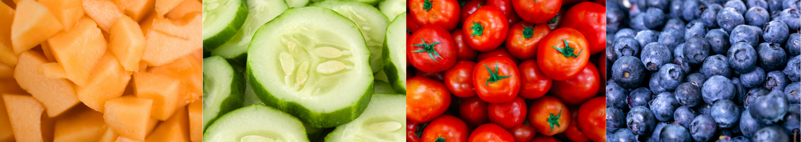

# Beaufort County Summer Menus for 2025

| **Monday** | **Tuesday** | **Wednesday** | **Thursday** | **Friday** |
| --- | --- | --- | --- | --- |
| Dunkin Stix  Assorted Juice  Milk  Pizza  Sweetcorn  Fresh Apple  Variety of milk | Muffin  Assorted Juice  Milk  Hamburger  Peas and Carrots  Fresh Peach  Variety of milk | Super Donut  Assorted Juice  Milk  BBQ Sandwich  Green Beans  Fresh Fruit  Variety of milk | Cinnamon Roll  Assorted Juice  Milk  Chicken Nuggets with Roll  Mashed Potatoes  Fresh Pear  Variety of milk | **Cereal**  Assorted Juice  Milk  **Turkey and Cheese on a Hawaiian Bun with Cheese Stick**  **Carrots with Ranch**  **Fruit Cup**  Variety of milk |
| June 16-20  July 7-11  July 21-25  August 4-8 |  |  |  |  |
| Cinnamon Toast Crunch Bar  Assorted Juice  Milk  Pizza  Peas  Pears  Variety of milk | Sweet Bread  Assorted Juice  Milk  Hot dog in a Bun  Baked Beans  Apple  Variety of milk | Fruit Strudel  Assorted Juice  Milk  Chicken Patty Sandwich  California Blend  Fresh Orange  Variety of milk | Mini Bagel  Assorted Juice  Milk  Baked Spaghetti with Breadstick  Mixed Vegetables  Variety of milk | Cereal  Assorted Juice  Milk  PB&J Uncrustable  Broccoli with Ranch Dressing  Diced Peaches  Variety of milk |
| June 23-27  July 14-18  July28-Aug 1  Aug11-15 |  |  |  |  |
|  |  |  |  |  |

## Families Making the Connection

### Bring the Farm to Summer

#NCFarmtoSummer benefits kids, School and Summer Nutrition Programs, schools, farms, families, and communities. Summer is the peak growing season for local farms. Purchasing locally grown food supports farmers and communities. Serving locally grown foods at their peak is best for quality, variety, taste, nutrition, and cost. #NCFarmtoSummer activities offer a fun, engaging opportunity to learn about agriculture, nutrition, and local food.

N.C. School and Summer Nutrition Programs, schools, community organizations, students, and families are encouraged to take the #NCFarmtoSummer Challenge:

* Serve and eat locally grown foods in meals and/or snacks.
* Learn and teach about locally grown foods, agriculture, and nutrition.
* Post or share about #NCFarmtoSummer activities. Tag @NCSchoolMeals, @Ray4NCKids, and @F2SCoalitionNC on social media.
* Plan to participate in the #NCCrunch to taste and learn about North Carolina-grown fruits and vegetables for #FarmtoSchool Month in October.

Find #NCFarmtoSummer resources at <https://bit.ly/3I5noab>.

Did you know N.C. Summer Nutrition Programs offer food, fitness, fun, and farm to summer for youth when school is out? Text FOOD or COMIDA to 304-304 to find summer meals near you. Or find info at [summermeals4nckids.org](https://summermeals4nckids.org).